COPY/PASTE THIS FIRST
Your Name
Your Job Title
T. Marzetti Company
380 Polaris Pkwy, Westerville OH 43082
Cell: (xxx) xxx-xxxx | Marzettifoodservice.com
Come back and copy/paste this logo separately.


Adding a signature to Outlook(Web)
- In settings, navigate to: Mail > Compose and Reply > Email Signature

- Click “+ New Signature” and name it. Copy and paste the above signature into the box.

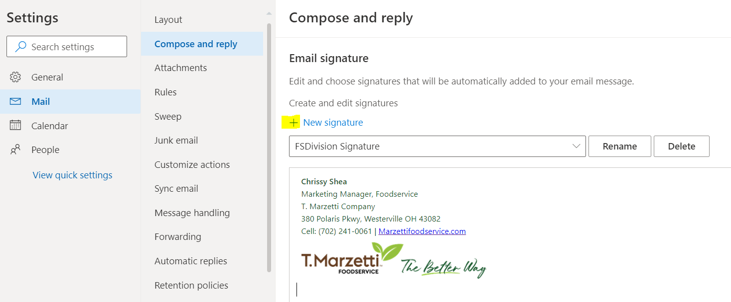

- IMPORTANT! Scroll down to choose this new signature for new emails and reply emails

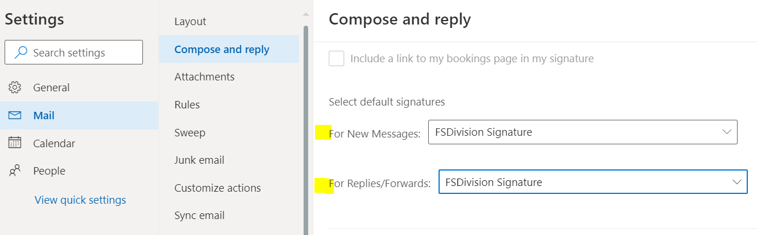
- Save it and email everyone you know

Outlook Desktop App (not in internet browser)

- Navigate to: File > Options > Mail > Signatures
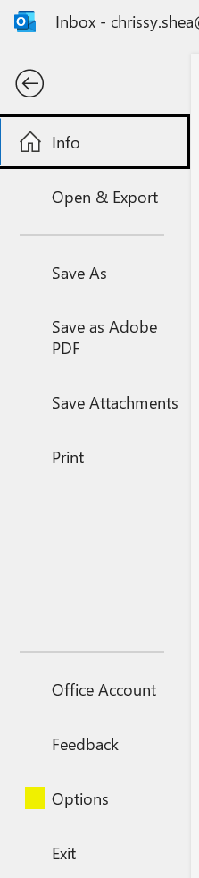
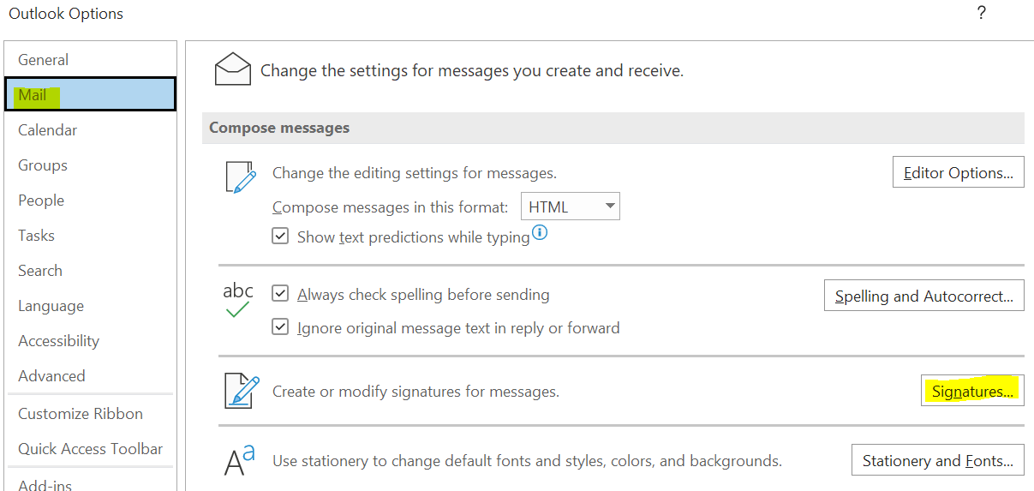

- Add and name a new signature
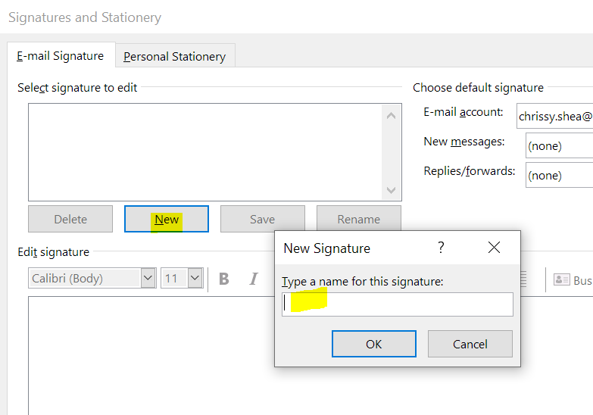
- Paste and personalize your signature, then choose the new signature from the drop down for new and reply emails (on right). Save it and email everyone you know.
